Alex Sutherland and Justin Tyner

ESOF 322 Homework 2

**A)**

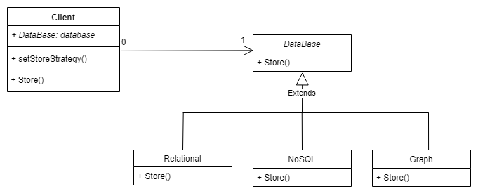

**B)**

package esof2;

import java.io.FileNotFoundException;

import java.io.PrintWriter;

import java.util.Scanner;

public class Client {

DataBase database;

void setStoreStrategy(String strategy){

if(strategy.equals("Relational")){

this.database = new Relational();

}

else if(strategy.equals("NoSQL")){

this.database = new NoSQL();

}

else if(strategy.equals("Graph")){

this.database = new Graph();

}

else{

System.out.println("Storage strategy not found.");

}

}

void store(){

if(this.database == null){

System.out.println("No storage method found");

}

else{

this.database.store();

}

}

}

public abstract class DataBase {

abstract void store();

}

class Relational extends DataBase{

void store(){

String fileName = "Relational.txt";

try {

PrintWriter outputStream = new PrintWriter(fileName);

outputStream.println("Relational Store");

outputStream.close();

} catch(FileNotFoundException e) {

e.printStackTrace();

}

System.out.println("Relational store called.");

}

}

class NoSQL extends DataBase{

void store(){

String fileName = "NoSQL.txt";

try {

PrintWriter outputStream = new PrintWriter(fileName);

outputStream.println("NoSQL Store");

outputStream.close();

} catch(FileNotFoundException e) {

e.printStackTrace();

}

System.out.println("NoSQL store called.");

}

}

class Graph extends DataBase{

void store(){

String fileName = "Graph.txt";

try {

PrintWriter outputStream = new PrintWriter(fileName);

outputStream.println("Graph store");

outputStream.close();

} catch(FileNotFoundException e) {

e.printStackTrace();

}

System.out.println("Graph store called.");

}

}

public class ESOF2 {

/**

* @param args the command line arguments

*/

public static void main(String[] args) {

Client client = new Client();

Scanner user_input = new Scanner(System.in);

String choice = " ";

while(!choice.equals("x")){

System.out.println("Enter c to change storage method, s to store data, or x to exit: ");

choice = user_input.next();

System.out.println(" ");

if(choice.toLowerCase().equals("c")){

System.out.println("Which storage method would you like to use?");

System.out.println("options: Relational, NoSQL, or Graph");

String method = user_input.next();

System.out.println(" ");

client.setStoreStrategy(method);

}

else if(choice.toLowerCase().equals("s")){

client.store();

}

else if(choice.toLowerCase().equals("x")){

System.out.println("Program ended");

}

else{

System.out.println("command not recognized");

}

}

}

}

**Program Output:**

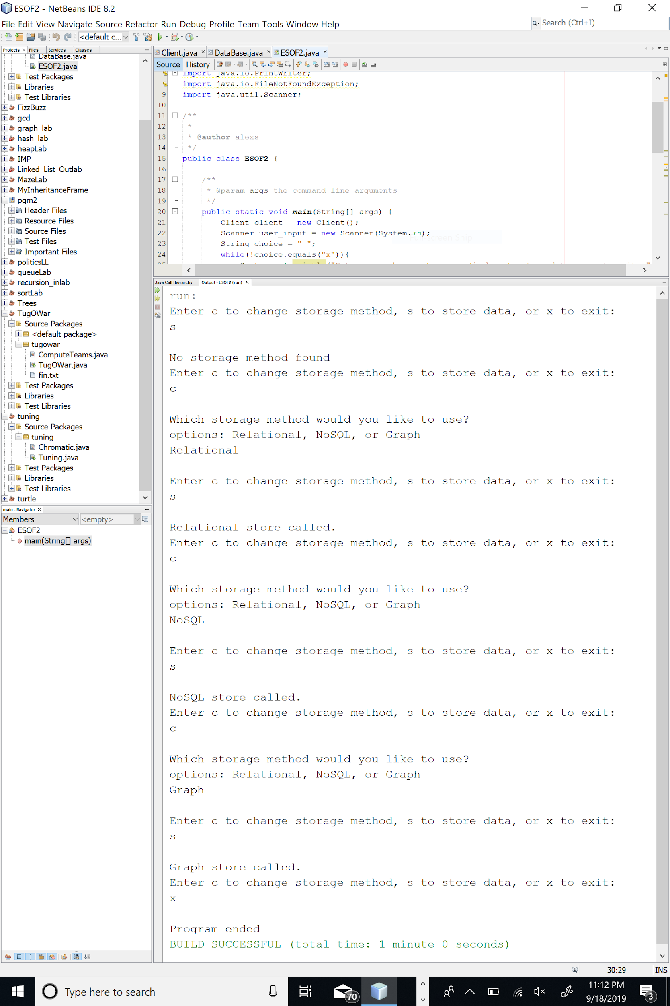

**C)**

